**GREENWOOD COLLEGE**

**Mathematics Methods Units 3 & 4**

**Test 5 Logarithmic Functions 2019**

Name Mark /33

**All electronic devices must be switched off and in bags.**

**Access to Formulae Sheet allowed. No notes.**

**No calculators allowed in this section. Time limit 35 minutes.**

1. [ 4,4 = 8 marks]

Solve the following equations using logarithms:

a) b)

2. [ 4 marks]

Solve for $x$: $\log_{4}{x^{3}+\log_{2}{\sqrt{x}=8}}$

**3 [2,2 = 4 marks]**

Determine the following antiderivatives:

**a)**  **b)** 

**4. [2,1,2 = 4 marks)**

**a)** Determine the derivative of y = 

**b)** Hence find 

**c)** Use your result to find the exact value of 

**5. [3 marks]**

Show that

6. [ 2,3 = 5 marks]

a) Differentiate $xlnx-x$ to find $\int{lnx dx}$

b) Hence determine the shaded area shown under the function .

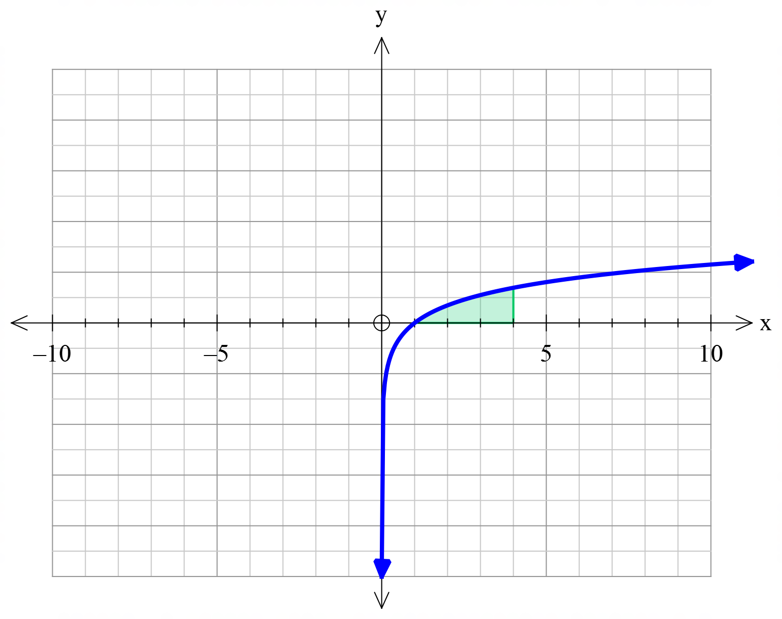

7. [ 2,3 = 5 marks]

Both graphs A and B shown below are in the form $f\left(x\right)=\log\left(x-a\right)+b$. State the variables $a$ and $b$ for each graph.

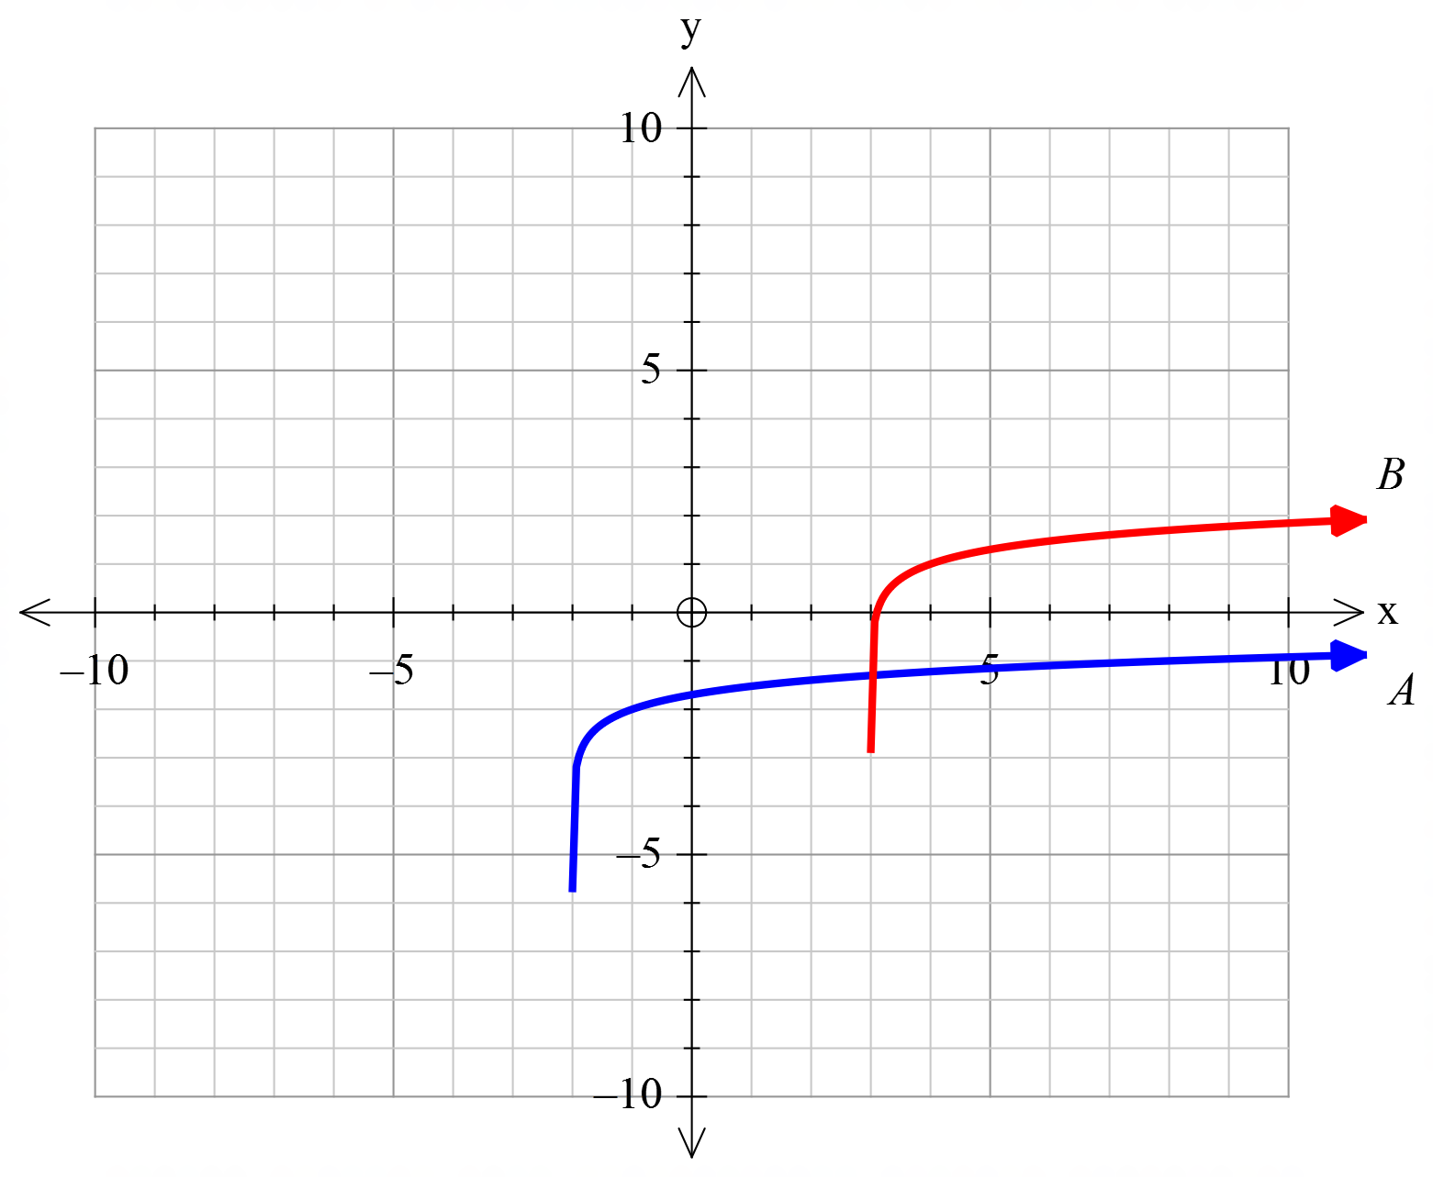

END OF SECTION

**GREENWOOD COLLEGE**

**Mathematics Methods Units 3 & 4**

**Test 5 Logarithmic Functions 2019**

Name Mark /23

**All electronic devices must be switched off and in bags.**

**Access to Formulae Sheet and one sheet of A4 notes allowed. Use of approved calculators is assumed in this section.**

**Time limit 20 minutes.**

8. [ 1,1,2 = 4 marks]

Let $f\left(x\right)=\int_{1}^{x}{\frac{1}{t}dt}, x>0$

a) State a simplified expression for $f(x)$.

b) Hence evaluate $f\left(5\right)$, rounded to 2 decimal places.

c) State an exact value for .

9. [ 2,2,2 = 6 marks]

A clothing manufacturer makes two popular items of clothing: jumpers and cardigans.

The profit , $P$ in tens of thousands of dollars from the manufacture and sales of $x$ thousand jumpers is given by $P_{j}=2\log{(x+0.75)}$. The corresponding profit for cardigans is given by $P_{c}=3\log{(x+0.5)}$. Assuming all the items produced are sold, determine:

**a)** the number of jumpers needed to be produced for the jumpers product line to break even.

**b)** The number of each item that needs to be produced and sold for the two product lines to make the same profit

**c)** the number of jumpers that need to be produced for the jumpers to make more profit than the cardigans.

10. [3,3,1 = 7 marks]

**a)** Show that the gradient of the curve  at the origin is 0.

**b)** The graphs of ,  and  are shown below.



1. Determine the exact value of , , given that the shaded region has an area of 6 square units.

**ii)** Determine the exact area between  and the -axis from  to .

11. [ 2,2,2 =6 marks]

At the start of a plague of grasshoppers the population doubles every 4 days.

a) Explain why the Population after $t$ days might be modelled by the equation

$P\left(t\right)= P_{0}×2^{\frac{t}{4}}$

**b)** How long will it take the population of 2000 to grow to 64000 ?

**c)** Show that the equation for $t$ in terms of $P$, given an initial population of 2000, can be expressed as .

$$t=\frac{4\log{P/{2000}}}{\log{2}}$$

END OF PAPER